COMP2113 Programming Technologies /

ENGG1340 Computer Programming II

**Module 6 Checkpoint Exercise**

Name: Zhao Kexin

University ID: 3035845368

**Instructions:**

For each single question or each group of questions in the Checkpoint exercise, please type your answer right after the question in this Word document.

**Checkpoint 6.1 (Please submit your answer to Moodle)**

There may be error(s) in the following statements. Correct the error(s) if any, if no error, please write “no error”.

a) double a [1] [2] = {{2,3}, {3,2}};

double a [2] [2] = {{2,3}, {3,2}};

b) double b [1] [2] = {{3}};

no error

c) char b[1000] = "string";

no error

**Checkpoint 6.2 (Please submit your answer to Moodle)**

Consider the following code:

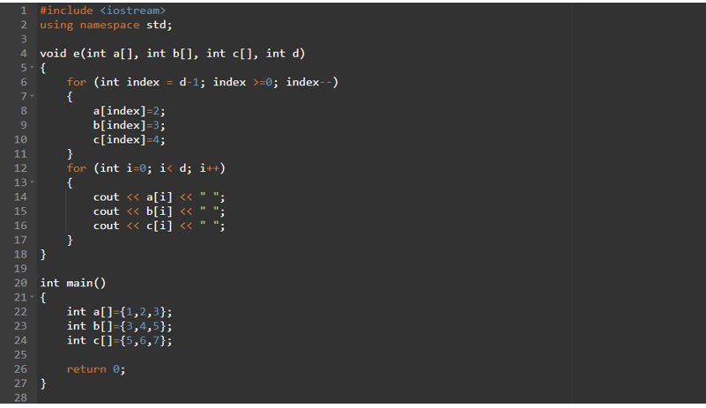

a) What is the output if the above program is executed? (if no output, please write “no output”)

no output

b) What is the output if e(a,b,c,3); is added to line 25? (if no output, please write “no output”)

234234234

c) What is the output if e(a,b,c,5); is added to line 25? (if no output, please write “no output”)

no output

**Checkpoint 6.3 (Please submit your answer to Moodle)**

Assume a 3D double array x is defined as

double x[2][2][3] = { { {3, 4, 2}, {0, -3, 9} }, { {13, 4, 56}, {5, 9, 3}}};

Write a program that would find the maximum and minimum values in this 2-by-2-by-3 double array x.

Print the maximum and minimum value after they are found.

#include <iostream>

using namespace std;

int main(){

double x[2][2][3] = {

{ {3, 4, 2}, {0, -3, 9} },

{ {13, 4, 56}, {5, 9, 3}}};

int max_value=x[0][0][0], min_value=x[0][0][0];

for (int i=0; i<=2; i++){

for (int j=0; j<=2; j++){

for (int k=0; k<3; k++){

if (x[i][j][k] >= max_value){

max_value = x[i][j][k];

}

if (x[i][j][k] <= min_value){

min_value = x[i][j][k];

}

}

}

}

cout << max_value << endl;

cout << min_value << endl;

return 0;

}

max: 56

min: -3